ULPS - Telehealth COVID-19 Process

# All ULPS Front Office Staff, Nurses, MAs, Physicians

### Front Office Staff or Clinical Staff Creating Telehealth Appointments

1. **Contact the patient** and have a conversation to discuss having a telehealth visit.
2. **Does the patient agree to the telehealth visit?** 
   1. If the patient **agrees** to a telehealth visit, before you delete the original appointment, schedule the new appt as “**ULPS Telehealth–Home Visit**” in Revenue Cycle at the same date/time.  
      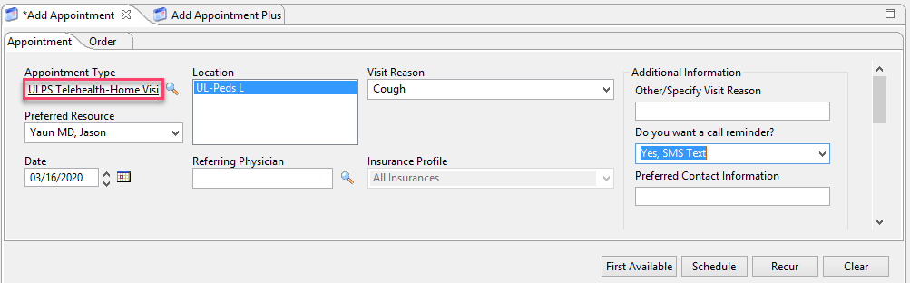
   2. To add to the same FIN number as the original appointment:
      1. 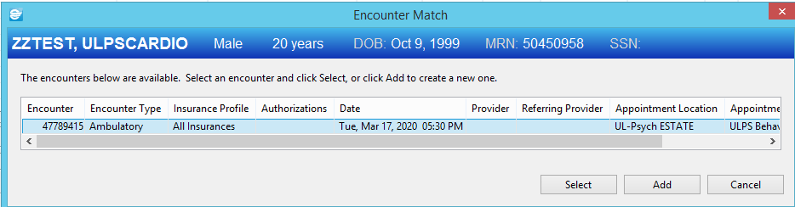When you click “confirm”, you will see the below prompt. Click on the original encounter shown in the box and then click “select”:
   3. Then, go in and delete the original scheduled appointment.
   4. If the patient **disagrees** to a telehealth visit, you can explore a billable telephone encounter with the Physician/APP or let them know you will cancel their appointment and call them back when we can reschedule them to come in the office. Send a message to the division’s Message Center Admin pool as a reminder.
   5. If the patient chooses to schedule a **telephone call** in place of their appointment, you can schedule it as a ULPS Telephone Visit appointment type.
3. **Email the patient the consent form.** 
   1. Verify patient’s email through Revenue Cycle. If they do not have an email, add it.
   2. Copy this information and paste it into the email:

(Note: you can add your email address as well if you would like to receive the telehealth consent back in your inbox as an FYI. You do not need to print this out or have it labeled for HIM as long as the [ULPStelehealth@lebonheur.org](mailto:ULPStelehealth@lebonheur.org) is in the link.

i.e. <https://secure.lebonheur.org/apps/mymlh/telehealth/?site=lebonheur&email=ulpstelehealth@lebonheur.org,jane.smith@lebonheur.org> (You must correct the underlying hyperlink when adding your email address, instructions for that are at the end of this document)

Dear Parent/Guardian,

Please click on the link below to access the Telehealth Consent Form. Please complete the information and click “submit”.

<https://secure.lebonheur.org/apps/mymlh/telehealth/?site=lebonheur&email=ulpstelehealth@lebonheur.org>

Due to the increased volume of phone calls we are receiving, please consider signing up for the patient portal to communicate with our staff and physicians electronically.

You can receive testing results, view clinic notes, and submit questions/concerns directly to the clinic. Please click the link below to sign up:

<https://secure.lebonheur.org/apps/mymlh/login/>

[Thank you for choosing UT Le Bonheur Pediatric Specialists. Please contact us with any questions or concerns at (901) 287-7337.](https://secure.lebonheur.org/apps/mymlh/login/)

**(The Spanish versión of this is located on the next page)**

Estimado padre/madre/tutor,

Presione sobre el enlace que está aquí abajo para ingresar el Formulario de consentimiento para telesalud. Por favor complete la información y elija “Estoy de Acuerdo” *(“I Agree”)*.

<https://secure.lebonheur.org/apps/mymlh/telehealth/?site=lebonheur&email=ulpstelehealth@lebonheur.org&lang=es>

Debido a la gran cantidad de llamadas telefónicas que estamos recibiendo, por favor considere la opción de registrarse en el portal electrónico para pacientes para poder de este modo comunicarse con nuestro personal y doctores de manera electrónica.

Usted puede recibir resultados de estudios, ver las notas clínicas y enviar preguntas / inquietudes directamente a la clínica. Por favor presione sobre el enlace aquí abajo para registrarse:

<https://secure.lebonheur.org/apps/mymlh/login/>

Gracias por elegir a los Especialistas Pediátricos de la Universidad de Tennessee y Le Bonheur. Por favor contáctenos con cualquier pregunta o inquietud al (901) 287-7337.

* 1. Send the consent link to the patient via email. Stay on the phone with the patient and ask them put you on speakerphone while they complete the consent and verify they have “submitted”.
  2. Once the patient submits, the consent goes to a monitored email address and will be sent to HIM to be entered into the chart.
  3. Once the patient completes the consent, they receive a prompt to download the **VidyoConnect** app on their phone/computer.

1. **Complete a “test visit” with the patient.**
   1. Tell the patient to be in a quiet, well-lit area, free of background noise.
   2. Send the patient a link to your personal VidyoConnect room. They must have VidyoConnect downloaded first.
   3. The link can be found and sent to the patient by clicking Rooms > Selecting your Personal Room > Send Invitation > A new email will pop up in outlook with the information > Enter the recipient’s email address > Send
   4. You must have the Outlook Email desktop application open on your computer when you click “Send Invitation”.
   5. OUTLOOK SETUP IS NOT REQUIRED FOR USAGE OF THE VIDYO APP. It is simply a means of making the sending the invitation easier.
   6. This method of sending the invitation will only work when using your personal room or a room that you “own”.

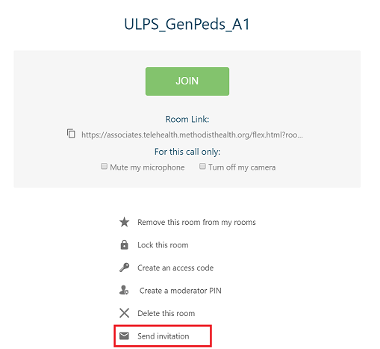

* 1. **You must hang up the phone with the patient to perform the test visit.**
  2. Once you complete the test visit and patient submitted consent, confirm the scheduled visit. Tell the patient that you will send them a link to the correct room 30 minutes to 1 hour prior to the scheduled visit.
  3. Give the patient a direct line to contact you in case there are issues getting into the VidyoConnect room.

**The day of the visit:**

1. About 30-minutes before the visit, send the patient the link to the virtual room.
2. At the scheduled time of the visit, join the room you sent the patient.
3. When you connect with the patient, the patient will need to be “Checked In” in Revenue Cycle. Verify demographics such as address, alternate numbers, insurance, etc.
4. Verify the patient and legal guardian are present. **Use two patient identifiers**.

**Document the Visit:**

#### Facilitator of telehealth call (i.e., nurse, MA, etc.)

1. The person initiating the call should go to Documentation > PowerNote > Choose “Telehealth Note” type > Choose Telehealth Note encounter pathway template.  
   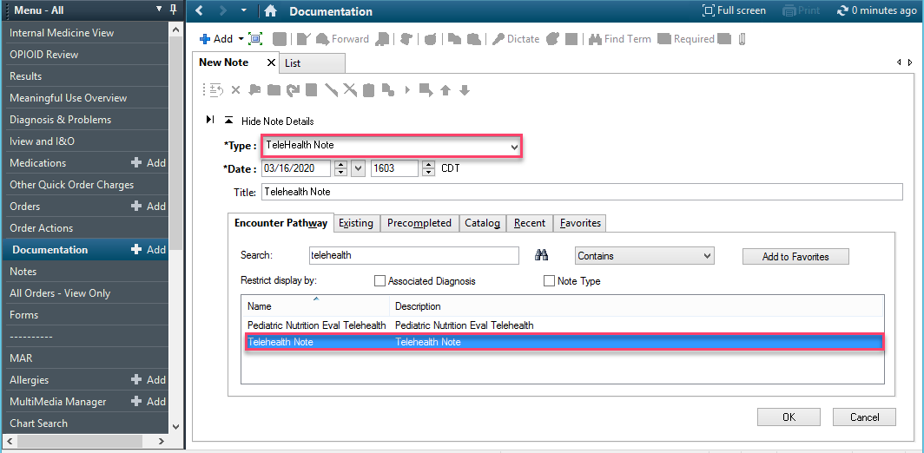
2. Document all necessary information, and Sign/Submit.
3. To choose consulting physician location (attending physician), click on the three small blue dots. Consulting physician location should always be “Le Bonheur Children’s Hospital”  
   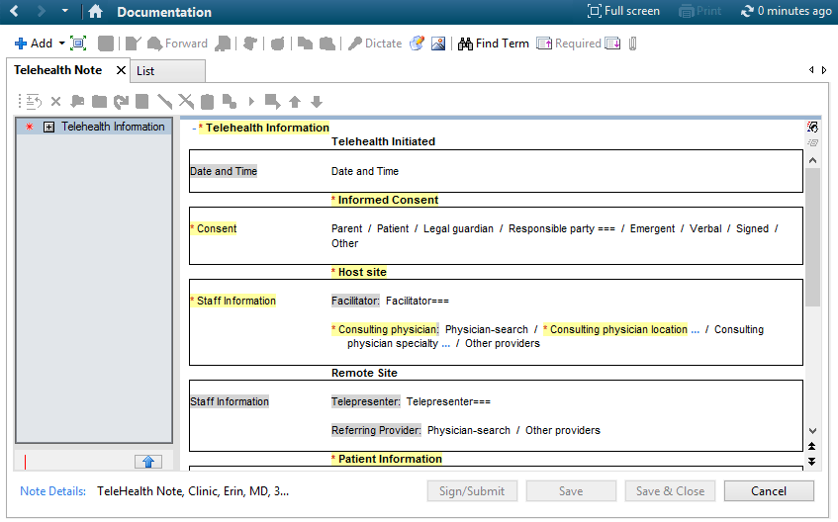
4. Go to Pediatric Ambulatory Intake Form and perform/document as much of your routine intake as possible. Sign the note.
5. Remember to “Check Out” patient in Revenue Cycle when the visit is complete.

#### Physician/APP

* Physicians should use their regular note types from clinic but should indicate in the **Title** line that it’s a telehealth note (i.e. Cardiology Return Telehealth Note).
* AUTOTEXT: An autotext is available to add to your note regarding COVID-19. Type **//z_tele_home**.
* 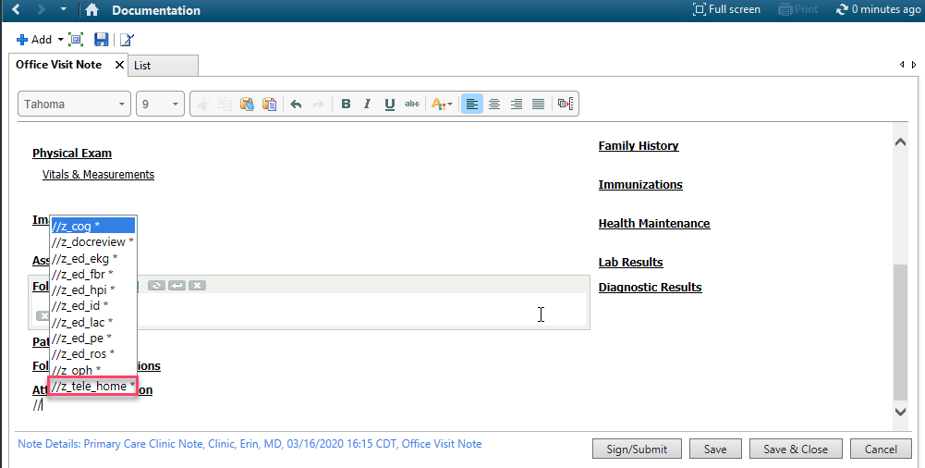You can modify this information if the patient is being seen via Telehealth in another location. Please include the state you are physically located in and the state the patient is physically located in at the time of the visit.

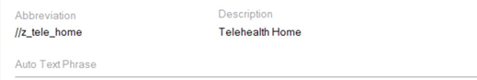

* When entering your charges, add the modifier **GT**. This is old, but you can still access it. This will allow the charges to be managed on the back-end for compliance purposes so payers will pay the charges. (You do NOT need to choose the telehealth Performing Discipline).  
  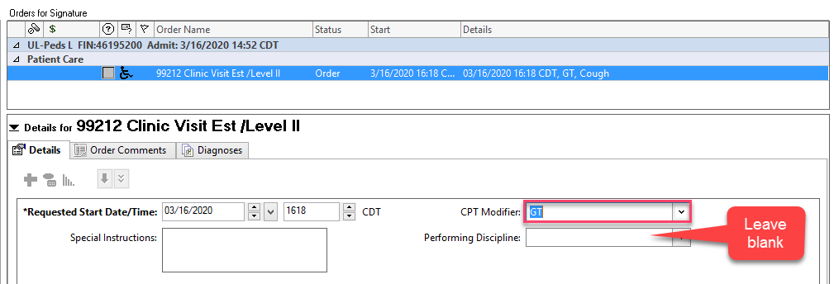
* 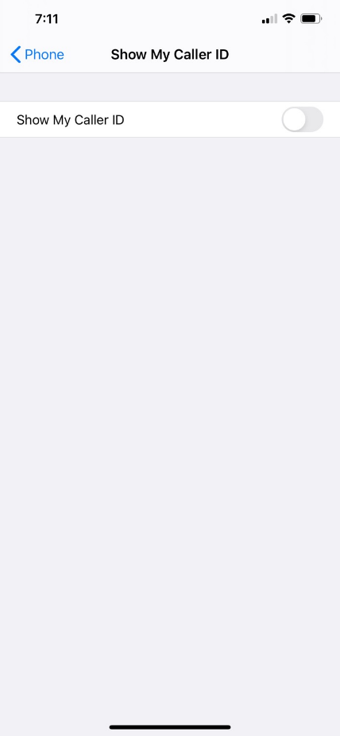If you are at home and need to call a patient, you can “hide” your personal iPhone cell number so it shows **Restricted**.   
  Settings>Phone>Show My Caller ID>Toggle switch to hide
* When performing a telehealth visit, it is important not only to maintain the privacy of the patient on the telehealth video conference, but also any patients in view of the camera used by the provider.

For assistance with the process, you can contact the clinical informaticists:

FYIs:

1. Do not create your own rooms in Vidyo Connect. If you need additional rooms, put in a general helpdesk ticket ATTN: Telehealth Team requesting rooms.
2. If not all parties “hang up” the call when the appointment is over, the room will show as locked. Most of the rooms are owned by [Jene.Huff@lebonheur.org](mailto:Jene.Huff@lebonheur.org) (with the exception of a few specialties) and she can unlock the room for you.

HYPERLINK INSTRUCTIONS:

1. If you are adding the your email address to the telehealth consent link, you can add it behind the end of the [ulpstelehealth@lebonheur.org,jane.smith@lebonheur.org](mailto:ulpstelehealth@lebonheur.org,jane.smith@lebonheur.org) (a comma between, no spaces)
2. Right click on the link and choose “Edit Hyperlink…”
3. 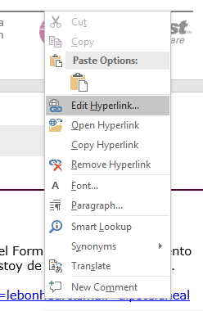
4. The display text AND the address text have to match (have to have the same email addresses in BOTH. If it’s only in the display text, it will not be used as part of the link.
5. 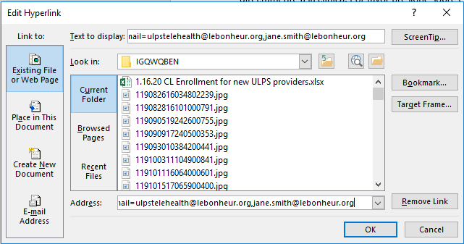

Raven McBride at [Raven.McBride@mlh.org](mailto:Raven.McBride@mlh.org) or (901) 354-4749.

Angel Davis at [Angel.Davis@mlh.org](mailto:Angel.Davis@mlh.org) or (901) 569-5605.

Jaleesa Larry at [Jaleesa.Larry@mlh.org](mailto:Jaleesa.Larry@mlh.org) or (901) 297-2495.

For troubleshooting connectivity issues during the visit, you can contact the Le Bonheur Transfer Center at (901) 287-4408.